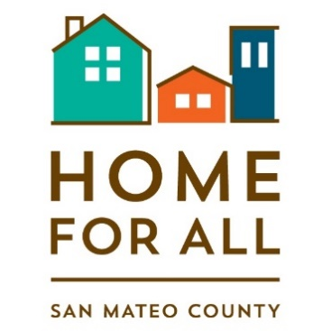
HOME FOR ALL COMMUNITY CONVENING
DEVELOPING NEIGHBORHOOD SUPPORT FOR NEW HOUSING:
INSIGHTS FOR ADDRESSING PARKING & CONGESTION CONCERNS
Toolkits

Housing and Mobility Toolkit Summary
When new housing is proposed, parking and traffic congestion are common local concerns. Communities around the Bay Area are exploring new approaches to alleviating these issues, including building new housing to bring people closer to their jobs. For this toolkit, Home for All partnered with Mineta Transportation Institute to showcase examples of successful, innovative housing and neighborhood mobility strategies that are applicable to San Mateo County. The Toolkit includes 13 case studies from cities in San Mateo County, the Bay Area and beyond. Topics within the Housing and Mobility Toolkit include Transportation Impact Analysis and the shift from Level of Service to Vehicle Miles Traveled, Transportation Demand Management, Transit Oriented Development, and Community Planning Processes. The Toolkit can found here: https://homeforallsmc.org/housing-mobility-toolkit/ The full case studies are also available to you at https://transweb.sjsu.edu/sites/default/files/1898-San-Mateo-County-Housing-Mobility-Toolkit.pdf

Grand Boulevard Initiative Transportation Demand Management (TDM) Toolkit
The Grand Boulevard Initiative Transportation Demand Management (TDM) Toolkit is part of an ongoing GBI effort to provide more information on best practices in use within the El Camino Real corridor, Bay Area, and beyond. TDM is the study of how people get around and what behavior change strategies encourage more people to take transit, rideshare, walk, bike, etc. The case studies demonstrate best practices and innovative approaches to TDM implementation. The case studies fall into four categories: Transportation Impact Analysis and TDM, neighborhood-level TDM approaches, integrating TDM into Specific Plans, and other unique TDM strategies. The toolkit is available at https://grandboulevard.net/toolkits/tdmtoolkit and will be updated regularly with new and innovative best practices.

