April 13, 2019
Pacifica Community Center
540 Crespi Drive, Pacifica, CA

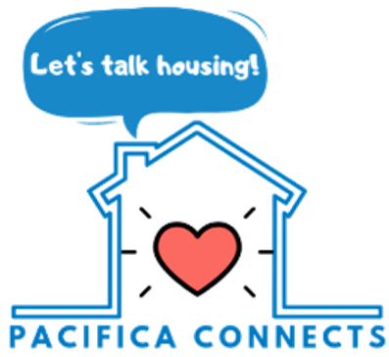

Agenda

9:30 AM Breakfast; Meet and Greet

10:00 AM Introductions & Goal: A Learning Meeting
Icebreaker: About Our Community
Presentation #1: Housing and Our Community
Table Discussion #1
Presentation #2: Housing Options to Consider
Table Discussion #2
Summary, Next Steps & Ways to Stay Involved

12:00 PM Meeting Adjourned; City Staff on Hand to Answer Questions

