Pacifica Community and Housing
April 2019
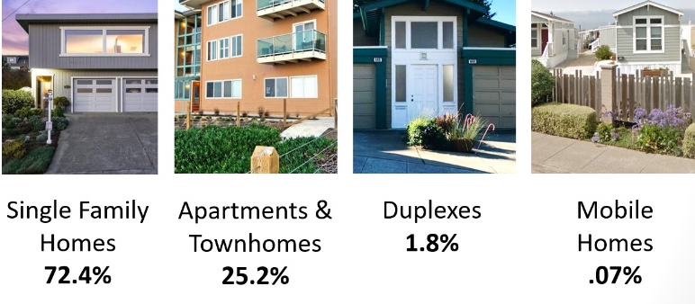
Diversity of Housing Types
Largest Local Industries
- Population of 39,141 people
- Median age of 42.2 years old
- Median family income of $106,959
- 85-93% of residents commute outside of Pacifica to work
- The average employee commutes
30.7 minutes to work

- 68% homeowners, 32% renters
- Current median home price of $1,050,000
- Median monthly mortgage payment of $5,263
- Current rent is $1,740 for a one bedroom,
$3,200 for a two bedroom
- Home buying takes 59% of median income
- Renting (2 BR apt.) takes 36% of median income
Who Lives and Works in Pacifica
Housing in Pacifica
Professional, Scientific,
Tech Services
Healthcare & Social Assistance
Retail Trade

Healthcare & Social Assistance
Addressing Our Community’s Housing Needs
As the cost of housing has risen throughout San Mateo County, increasing numbers of people are finding it difficult to pay rent or make monthly mortgage payments. Here in Pacifica, many of our fellow community members are struggling. Nearly one-third of our community has moved away in the last 10 years. Based on feedback received from an online questionnaire prior to this meeting, community members are particularly worried about housing options for their children, seniors, and low-income families, and are also concerned about preserving Pacifica’s existing community character.
What Comes Next?
Options to Consider
Communities throughout San Mateo County are considering creative ways to
address their housing needs. Today, we’ll discuss a range of options, including:
- Preserving existing housing
- Affordable housing funds
- Support for renters and homeowners
- Building new homes, including
mixed-use or employee housing
- Accessory dwelling units (ADUs)
- Home sharing
Collaborate Regionally
- Continue engagement
with San Mateo County
and other regional
partners on housing
Update & Modernize City Plans
- Update the General Plan, Local Coastal Plan and
New Sharp Park Specific Plan in 2019-2020
Community Conversation #2
- Continue the conversation on May 21
- Explore solutions and
ideas identified today
Pursue Innovative Solutions
- Think in new, creative
ways to find solutions
that reflect Pacifica’s
community values

